PRINTING:
Blank label (1) listed on the Bill of Materials for the individual label should conform to the following characteristics, but must be equivalent to previously validated materials
Label size: | 200 +/- 2 x 60 +/- 2
Stock: | Avery L7171 or equivalent
Adhesive: | Self-Adhesive
Ink: | Black

SOURCE:
Use COVIDIEN artwork 10050936 Rev.B

NOTES: UNLESS OTHERWISE SPECIFIED
- Printing specification and artwork carry same part number for control purposes.
- Visual representation not to scale, see artwork
- Vendor to supply material certification with each shipment
- All dimensions in are millimeters

200

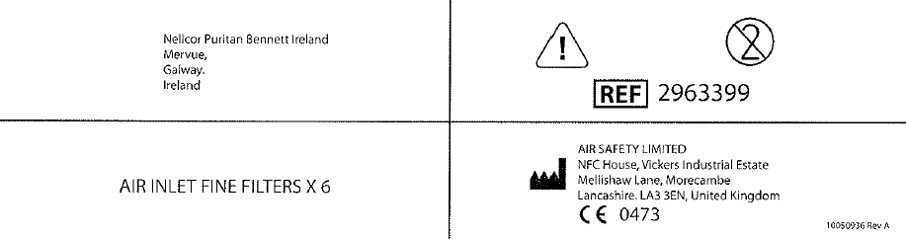
60

